Tender Form
Name of Work- Construction of Boundary Wall at East Campus, HBTI, Kanpur.
Estimated Cost-Rs.1757650=00
Time of Completion – 03 months Earnest Money-Rs.35000=00
Tender Form Cost - Rs.2300=00
Sl. No. | Description | Qty. | Rate | Total Amount
1. | Excavation in foundation in ordinary soil (loam clay or sand)including lift up to 1.50 M and lead up to 30M. And including filling, watering and ramming of excavated earth into the trenches or into the space between the building and the sides of foundation trenches or into the plinth and removal and disposal of surplus earth as directed by the Engineer incharge upto a distance of 30M from the foundation trenches for leveling 50x30x0.3. | 4.768cum
2. | Cement Concrete with 4cm Gauge approved stone ballast coarse sand and cement in the proportion of 8:4:1 including supply of all materials, labour& plant etc. required for proper completion of work. 2.5x20x0.15 | 2.473 cum
3. | R.C.C. work with cement approved coarse sand and 2 cm Gauge stone grit in proportion of 1:1.5:3 in lintels of door & windows excluding supply of reinforcement & its bending but including its fixing and binding of same with 24 B.W.G.G.I. , binding wire and including wire & including necessary centering & shuttering etc. & supply of all materials, labour, T & P etc. required for proper completion of work including the cost of binding wire . The rates exclude making of drip course which shall be paid extra. | 06.188cum
4. | R.C.C. work with cement approved coarse sand and 2 cm Gauge stone grit in proportion of 1:1.5:3 in lintels of door & windows excluding supply of reinforcement & its bending but including its fixing and binding of same with 24 B.W.G.G.I. , binding wire and including wire & including necessary centering & shuttering etc. & supply of all materials, labour, T & P etc. required for proper completion of work including the cost of binding wire . The rates exclude making of drip course which shall be paid extra. | 2.211cum
5. | R.C.C. work with cement approved coarse sand and 2 cm Gauge stone grit in proportion of 1:1.5:3 in lintels of door & windows excluding supply of reinforcement & its bending but including its fixing and binding of same with 24 B.W.G.G.I. , binding wire and including wire & including necessary centering & shuttering etc. & supply of all materials, labour, T & P etc. required for proper completion of work including the cost of binding wire . The rates exclude making of drip course which shall be paid extra. | 04.4cum
6. | M-150 Brick work in one cement&six fine sand mortar in foundation & plinth including supply of all materials, labour, T & P etc. required for proper completion of work | 16.18 cum
7. | 12mm thick cement plaster with cement & fine sand in proportion of 1:4 complete. | 90 sqm
8. | M.S. or iron work of small size & section such as holding down bolts, hold fast, tied grating etc. wrought to required form including supply of steel bolt, nuts, wastage etc. & their fixing required for proper completion of the work but in RCC.10 dia | 223.97 kg
9. | M.S. or iron work of small size & section such as holding down bolts, hold fast, tied grating etc. wrought to required form including supply of steel bolt, nuts, wastage etc. & their fixing required for proper completion of the work but in RCC. 16 dia | 492.41 kg
10. | M.S. or iron work of small size & section such as holding down bolts, hold fast, tied grating etc. wrought to required form including supply of steel bolt, nuts, wastage etc. & their fixing required for proper completion of the work but in RCC. 08 dia | 168.427 kg
11. | Finishing walls with one coat of water proof cement paint of approved make & quality on previously old treated surface with this paint to give an even shade including supply of all material, labour and tools and plants etc. required for proper completion of work. | 180 sqm
12. | S/F of MS gate, single leaf- 1.00x1.65 mtr. Complete including painting. As per bill | LS
13. | Unforeseen items. As per bill | LS
 | Above quantities are for 30 mtrs. Long boundary wall. So the amount for 200 mtrs. Long Boundary Wall is-
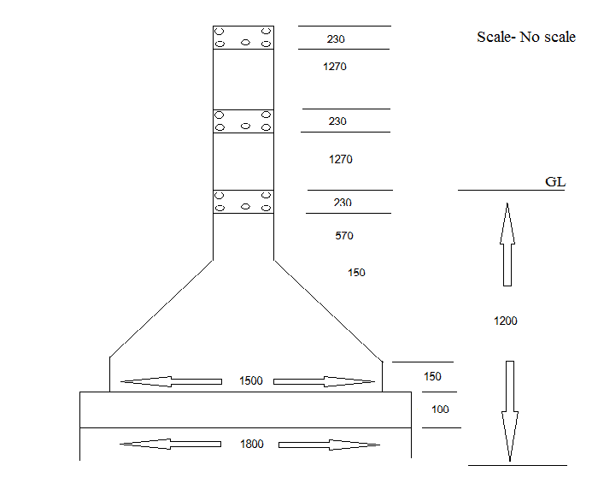
1500×1500- Footing- 10dia @ 150 C/C
230×230- Column- 16dia -04Nos
Stirrups- 8dia @ 200 C/C
230×230- Beam- 16dia -05Nos
Stirrups- 8dia @ 150 C/C
Terms & Conditions-
- All the work is to be executed as per PWD specification and norms.
- The contractor should attached a copy of TIN No.
- The contractor should attached a copy of PAN No. and copy of last year ITR.
- The contractor should attached a copy of registration certificate of state/central govt.
- An affidavit to the effect that firm is not black listed by any state/central Govt. Deptt.
- Satisfactory working certificate is necessary for similar type of work and amount.
- Annual turnover of the firm should be Rs 1.00 crore or more.
- The quantity may increase or decrease as per decision of competent authority.
- Without attachment of the above the tenders are not considered.
- In case of unjustified quoted rate below the tender cost, tender will be considered non-responsive and his/her earnest money will be forfeited.
- After allotment of said work security money (10%) will be deposited within a week, otherwise earnest money will be forfeited and work will allotted to second lowest.
- Any query about tender can be made from institute during working day and time.
- Payment will be made after completion and satisfactory report of the said work, running payment would made after satisfaction of work and recommendation of committee constituted by Director.
Name of work- Construction of Boundary Wall at East Campus, HBTI, Kanpur.

Signature of Contractor_________________________________________________________

Name, Address & Mobile no. of Contractor_________________________________________
____________________________________________________________________________________________________________________________________________________________

